**STUDENT DROP OUT ANLYSIS FOR SCHOOL EDUCATION**Sugashini K1,Sreenath G2 , Subash S B 3 ,Sakthivel S M4 ,Puja M S5

1 *Assistant Professor, Department Of Information Technology, Sri Shakthi Institute of Engineering and Technology, Coimbatore, Tamil Nadu,India.

2,3,4,5*.First Year B-Tech IT, Sri Shakthi Institute of Engineering andTechnology, Coimbatore,

Tamil Nadu, India.

**ABSTRACT:**

School dropout is still a serious problem with broad ramifications. This abstract examines the many facets of student dropout in education and provides a thorough study of it. It examines a range of issues, emphasizing their effects on students, including social, academic, and economical factors. It also addresses the serious repercussions of dropping out, highlighting the necessity of efficient interventions. The importance of technology, community involvement, and proactive tactics in lowering dropout rates is further emphasized in the abstract. This analysis seeks to address these important issues in order to offer insights and answers that are essential for promoting a welcoming and encouraging learning environment.

**KEYWORDS:**

Rates of Dropouts, Socioeconomic Elements, Academic Difficulties, Social Coercion, Interventions and Solutions for the Repercussions of Dropping Out, Early Detection, Assistance Initiatives, Participation of the Community.

**INTRODUCTION:**

The complicated problem of school dropout has significant effects on people, families, communities, and society as a whole. We'll examine the various facets of student dropout in school, including its causes, effects, and possible remedies, in this analysis. Dropout rates, which indicate the proportion of students who quit school before finishing their studies, are an important educational indicator. Examining these statistics necessitates looking into a number of variables that influence students' early withdrawal from the educational system. Socioeconomic Factors: Poverty, lack of resources, and financial restraints can make kids choose job over school. Academic Struggles: Disinterest and subsequent dropout might be caused by learning challenges, a lack of engagement, and inadequate support. A student's decision to quit school may be influenced by social pressures, bullying, and peer pressure, all of which have a detrimental effect on their mental health.



**DEFINING DROPOUT RATES:**

School dropout is still a serious problem with broad ramifications. This abstract examines the many facets of student dropout in education and provides a thorough study of it. It examines a range of issues, emphasizing their effects on students, including social, academic, and economical factors. It also addresses the serious repercussions of dropping out, highlighting the necessity of efficient interventions. The importance of technology, community involvement, and proactive tactics in lowering dropout rates is further emphasized in the abstract. This analysis seeks to address these important issues in order to offer insights and answers that are essential for promoting a welcoming and encouraging learning environment.

These rates are calculated by taking the total number of enrolled students or cohort at the start of the period and dividing it by the number of students that drop out of school within that time frame. The dropout rate can be broken down into distinct educational levels, such as elementary, secondary, or postsecondary, which helps identify the turning points in a student's education where disengagement is most likely to occur.

**CAUSE OF DROPOUT:**

There are many different factors that contribute to student dropout in education. Students frequently feel pressured by socioeconomic factors, such as poverty and financial limitations, to put work before school. Academic challenges like poor learning outcomes, a lack of support, and disengagement cause frustration and discouragement about continuing one's education. Social pressures that negatively affect students' mental health and influence their decision to drop out of school early include bullying, peer pressure, and difficulties integrating into society. These many variables combine to form a complex web that necessitates focused interventions to address systemic problems as well as personal difficulties in order to successfully lower dropout rates and assist students in their academic endeavors.



**CONSEQUENCES OF DROPING OUT:**

Significant ramifications result from dropping out of school, impacting many facets of a person's life. First of all, those without a high school diploma or its equivalent have fewer options for employment and further education. Economically speaking, dropouts frequently have lower earning potential, which feeds the cycle of poverty. Social feelings of inferiority, inadequacy, and low self-esteem arise and have an effect on mental health. Long-term effects go beyond the individual and affect communities and society by sustaining inequalities and impeding progress toward a common goal. To mitigate these consequences and establish a more equitable educational landscape, it is imperative to implement comprehensive support systems.



**INVENTIONS AND SOLUTION:**

Interventions aimed at preventing student dropouts include a variety of approaches. Early detection of at-risk students enables the provision of specialized assistance, such as tutoring, counseling, and mentorship, to address both academic and socioemotional difficulties. Establishing strong support systems in communities and schools fosters a welcoming atmosphere. Furthermore, timely interventions are made possible by utilizing data analytics to spot patterns and warning signs and leveraging technology to create flexible learning opportunities. Implementing and maintaining these interventions requires cooperation between educators, families, legislators, and communities in order to create an atmosphere that supports each student's successful completion of their education.

**LOOKING FORWORD:**

Prospective directions for innovation and focused interventions in student dropout analysis in education are apparent in the field's future. Technological and data analytics developments will be essential to early detection and intervention techniques. Proactive measures can be enabled by using predictive analytics to improve the identification of students who are at-risk. Further more, these predictive abilities can be improved by integrating machine learning and artificial intelligence models, providing individualized support based on the needs and learning styles of each individual student. This customized strategy can lower dropout rates dramatically by addressing the unique problems that students encounter. In addition, community involvement and cooperation will always be essential to creating environments that are encouraging to students. Building more connections between families, local groups, schools, and legislators will guarantee a more comprehensive approach to dropout prevention. Policies pertaining to inclusive education that recognize and accommodate a range of socioeconomic backgrounds, learning preferences, and cultural distinctions will become more and more essential. The goal of these regulations should be to establish learning environments where each student feels encouraged, supported, and empowered to succeed.

**LITERATURE REVIEW:**

**SOCIO-ECONOMIC FACTORS:**

Studies by Crosnoe & Johnson (2011) and Rumberger (2011) highlight the substantial relationship between socio-economic status and dropout rates. Dropout rates are greatly impacted by the difficulties that low-income families frequently face, including a lack of resources, insufficient parental involvement, and a higher frequency of work obligations for students.

Moreover, as examined by Balfanz & Byrnes (2012) and Fry (2007), the intersectionality of socioeconomic factors with race and ethnicity clarifies the differences in dropout rates between various demographic groups. Students of color, particularly those from underprivileged backgrounds, frequently experience additional difficulties that raise their risk of dropping out.

**SCHOOL CLIMATE AND ENVIRONMENT:**

As studies by Wang & Eccles (2012) and Thapa et al. (2013) have shown, it is imperative to examine school climate. Peer interactions, school safety, and teacher-student relationships are all important factors that have an impact on students' decisions to stay in school or not.

**POLICY INTERVENTIONS:**

According to Dynarski et al. (2008) and Bettinger (2012), interventions and policies have yielded varying outcomes. While some policies aimed at lowering dropout rates—such as those that center on financial aid, mentoring programs, or alternative education models—have shown to be successful, others have had less success because of implementation issues.

**INDIVIDUAL CIRCUMSTANCES AND STUDENT FACTORS:**

Jimerson et al. (2008) and Archambault et al. (2009) have conducted substantial research on individual student circumstances, which include academic performance, motivation, engagement, and personal experiences. Knowing these elements facilitates the creation of focused interventions for students who are considered to be at-risk.

**TECHNOLOGY AND DROPOUT PREVENTION:**

Research on the topic has recently begun, with studies by Means et al. (2013) and Clark (2015). Students who might otherwise become disengaged from traditional educational settings have shown promise in responding to personalized education, online learning, and adaptive technologies.



**LONG-TERM EFFECTS OF DROPOUT:**

Rumberger & Lim's (2008) and Levin, Belfield, & Muennig's (2012) longitudinal studies demonstrate the extensive ramifications of dropping out, which include decreased earning potential, fewer career options, and increased risk of engaging in criminal activity.

**UTILIZED INDICATORS:**

To find trends that point to a student's possible risk, EWS examines a variety of data points, including attendance logs, course grades, results from standardized tests, behavior reports, and credit accumulation.

**RISK IDENTIFICATION:**

EWS can identify students who do not meet the required standards by establishing benchmarks or thresholds for these indicators. For example, persistent absences from school, failing grades in several subjects, or disruptive behavior could set off an alert.

**TIMELY INTERVENTION:**

By giving educators, counselors, and administrators timely alerts, EWS enables them to take immediate action. Early identification makes it possible to provide at-risk students with more resources, individualized support, or targeted interventions.

**COLLABORATIVE APPROACH:**

Teachers, counselors, administrators, and occasionally even community organizations work together to implement effective EWS. Working together makes it easier to support students holistically, addressing meeting their emotional, social, and academic needs.

**PROGRESS TRACKING:**

An essential component of EWS is the ongoing observation and recording of students' progress. These systems are used by schools not only to identify students who are considered to be at-risk but also to evaluate the efficacy of interventions and modify their approaches accordingly.

**DISCUSSION:**

**ROOT CAUSES:**

Numerous underlying factors can contribute to high rates of student dropout. Significantly contributing factors include mental health conditions, family dynamics, societal pressures, academic difficulties, insufficient support networks, socioeconomic gaps, and disengagement from education brought on by a mismatch in teaching approaches and learning styles. Premature school leaving can also be influenced by other factors, such as bullying, substance abuse, low motivation, and restricted access to resources or extracurricular activities. Effectively addressing the intricate interplay of these issues is essential to reducing dropout rates.

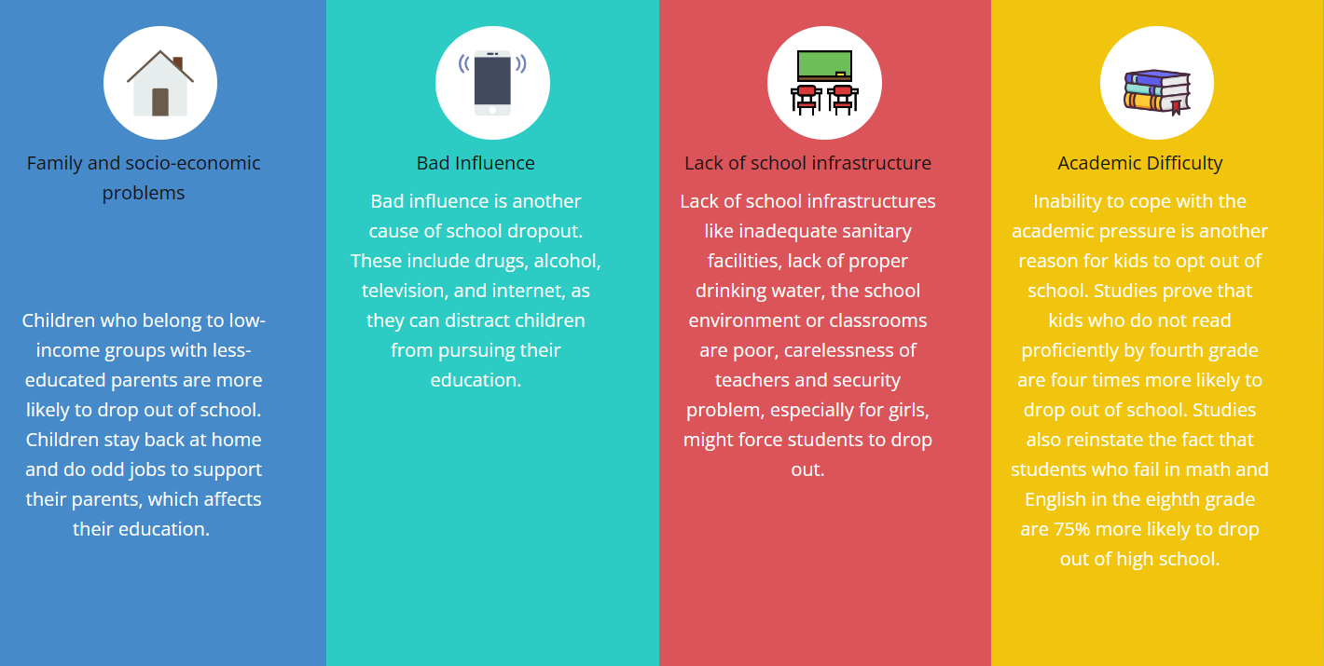

**DEMOGRAPICS:**

Understanding student dropout rates requires an understanding of demographics. Dropout trends are greatly impacted by variations based on ethnicity, socioeconomic status, geography, and cultural background. Because of systemic injustices in the educational system, a lack of resources, and insufficient support networks, marginalized communities frequently confront more difficulties. Certain demographic groups may be disproportionately affected by factors such as language barriers, immigration status, and access to high-quality education, which can result in higher dropout rates. Promoting inclusivity and minimizing gaps in educational outcomes require designing interventions and support systems to specifically address the needs of diverse populations.

**INVENTION STATERGIES:**

Implementing early identification protocols to address academic, social, or emotional difficulties, mentorship programs that pair struggling students with committed teachers or peers, and individualized support systems are some intervention strategies that can lower student dropout rates. Furthermore, providing alternative learning pathways, opportunities for vocational training, and community engagement programs can offer students at risk of dropping out a variety of avenues and ensure that they feel supported and involved in their educational journey.

**POLICY AND SYSTIMIC CHANGES:**

Revision of the curriculum to make it more inclusive and engaging, implementation of flexible learning structures to meet the needs of a diverse student body, and funding for mental health support and counseling services within educational institutions are some of the policy and systemic changes targeted at lowering the rate of student dropouts. Furthermore, the implementation of mentorship programs, cultivation of a positive school climate, and establishment of collaborations with community organizations can augment students' feelings of inclusion and assistance. Restructuring the educational system to reduce dropout rates requires addressing socioeconomic disparities, ensuring equitable access to resources, and reevaluating assessment techniques to emphasize holistic learning.



**DATA ANALYSIS:**

Analyzing data to identify vulnerable groups entails looking at trends across demographics in order to understand student dropout rates. Disengagement risk factors can be identified by examining attendance records, academic performance metrics, and socioeconomic factors. Early intervention strategies are made possible by the use of predictive modeling techniques, which help forecast potential dropouts. Additionally, educational institutions can create focused programs that cater to the needs of at-risk students, modify interventions, and allocate resources efficiently with the help of data-driven decision-making. This analysis aids in the development of well-informed interventions and policies to lower dropout rates and raise overall student retention.



**COMMUNITY INVOLVEMENT:**

Participating in educational initiatives that involve local businesses, organizations, and families is one way that the community can help lower the dropout rate of students. By providing career counseling, tutoring, and mentorship, this involvement creates a network of support. Working together with local authorities facilitates addressing socioeconomic issues that have an impact on students' education. Incorporating parents into school events and decision-making procedures enhances the relationship between the home and the school. Resources for counseling services or after-school programs are made available through partnerships with civic organizations or nonprofits. Diverse support networks are established and a community-wide commitment to education fosters an atmosphere where students feel appreciated and motivated to continue their education.

**POST DROP OUT SUPPORT:**

Post-dropout support entails developing re-entry programs that provide alternative forms of education, like flexible learning options, GED preparation, or vocational training. Facilitating opportunities for counseling and mentorship can help students reintegrate into the educational system. Working with neighborhood organizations to offer job placement or skill-building initiatives gives dropouts the confidence to pursue rewarding careers. These people will always have support and follow-up to help them on their educational or professional journeys. In addition to offering opportunities for personal and professional development outside of traditional academic settings, creating a supportive environment for dropouts encourages them to re-engage with learning.



**LONG TERM IMPACT:**

Reducing student dropout rates has long-term effects that affect not just individual lives but also economies and societies. By lowering dropout rates, we develop a workforce that is knowledgeable and skilled, which promotes innovation and economic growth. Reduced dropout rates improve overall societal well-being by lowering unemployment and poverty rates. Additionally, it promotes a culture of lifelong learning, empowering people to have a positive impact on coming generations. Societies gain from lower social welfare expenditures and higher levels of civic participation, which build stronger and more prosperous communities. In the end, reducing dropout rates leaves future generations with a legacy of advancement, equality, and opportunity.

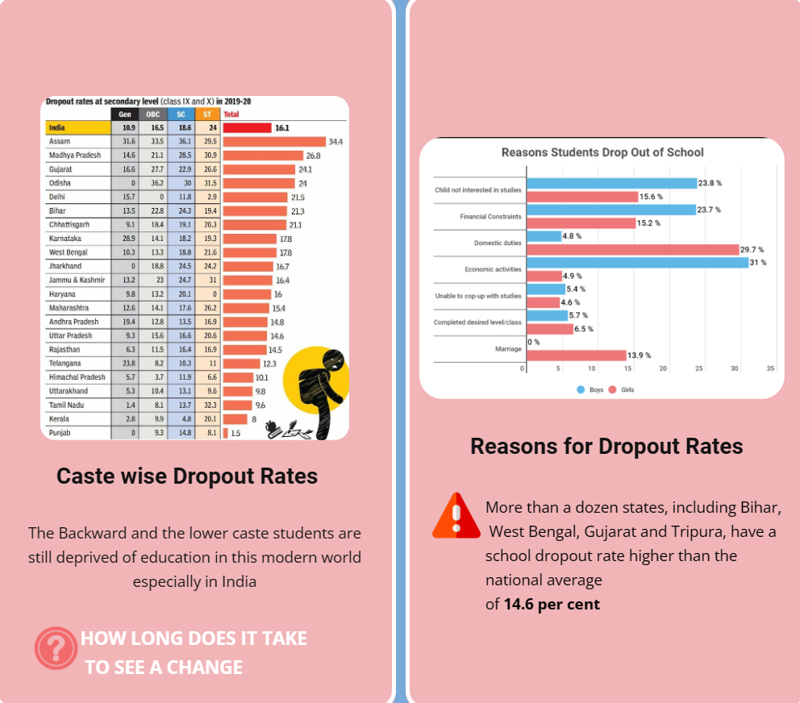

**SUCCESS STORIES:**

The Diplomas Now program is a noteworthy example of success, as it employs a combination of data analysis, individualized support, and community involvement to effectively reduce dropout rates in participating schools by 50%. The City Year program also offers tutoring and mentoring, which raises graduation rates in underprivileged areas. Establishing career-focused academies in schools, such as the Linked Learning model, is another effective strategy that raises graduation rates and student engagement by fusing academics with real-world experiences. These success stories highlight how successful it is to reduce dropout rates and promote student success through customized interventions, data-driven tactics, and teamwork.

**CONTINOUS ASSESMENT:**

Continuous assessment is the process of continuously assessing dropout prevention tactics and refining interventions based on data. Adaptability is ensured by routinely reviewing the efficacy of support systems, analyzing student progress, and spotting trends. Collaborative improvement is fostered when stakeholders, including educators, students, families, and communities, are involved in feedback loops. Agile methodology implementation enables quick adjustments to meet changing

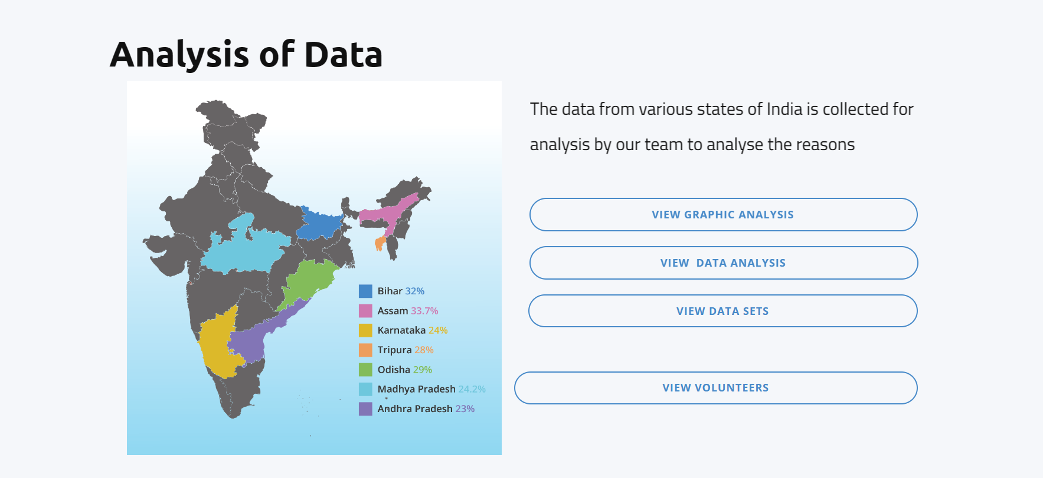

student needs. Adopting cutting-edge tools and methods for instruction guarantees their applicability and effectiveness. Through this iterative process of assessment and improvement, educational institutions can maintain a dynamic, proactive, and responsive environment that lowers dropout rates and fosters student success.

**CONCLUSION:**

Developing a comprehensive understanding of and response to student dropout rates is essential to creating an inclusive and productive learning environment. As we draw to a close, it is clear that student dropout rates are more than just a statistical measure; rather, they are a reflection of intricate underlying factors entwined in the domains of education, society, and the individual.

The understanding that every dropout is a distinct story shaped by a variety of obstacles—academic difficulties, socioeconomic inequalities, mental health issues, or disengagement from the educational setting—lies at the core of this problem. These difficulties highlight the need for comprehensive strategies and multimodal interventions that take into account the various needs and experiences of students.

Finding early warning signs is essential to any solution. Ineffective attendance, deteriorating academic performance, behavioral problems, or disengagement are not just symptoms; they are warning signs that need to be addressed right away. Here, data analysis is essential because it enables educators and other stakeholders to identify trends, forecast dropout rates, and create focused interventions. By using data-driven decision-making and predictive modeling, educational institutions can intervene early and provide at-risk students with specialized support.

A variety of techniques are included in intervention strategies, such as alternative learning pathways, community involvement, and mentorship programs in addition to individualized support networks. While alternative pathways accommodate a variety of learning styles and interests, guaranteeing that no student is left behind, individualized attention and mentorship can offer the vital support that struggling students require.

Moreover, systemic and policy changes are necessary for long-term advancement. Crucial actions include developing a positive school climate, providing resources for mental health support, and updating the curriculum to be more inclusive and current. Restructuring the educational system to reduce dropout rates must start with addressing socioeconomic disparities and providing equitable access to resources. Diverse student needs are accommodated by flexible learning structures and assessment techniques, making education both accessible and interesting for everyone.

The effectiveness of holistic approaches is demonstrated by success stories and best practices from diverse initiatives. Initiatives such as Linked Learning, City Year, and Diplomas Now show how data-driven tactics, individualized guidance, and community engagement can lower dropout rates and increase student achievement.

On this journey, it is imperative to continuously assess and improve. Interventions stay effective and responsive when they are regularly evaluated, involve stakeholders, and adopt new technologies and methods. Since education is a dynamic ecosystem, continuing progress in lowering dropout rates depends on the capacity to adjust and improve methods.

In summary, reducing the number of students who drop out of school requires a team effort involving educators, legislators, families, communities, and the students themselves. It demands a change in approach from reactive to proactive, preventive interventions. Through the cultivation of an inclusive, supportive, and ever-improving culture, we can establish learning environments in which each student feels empowered, appreciated, and supported to succeed.

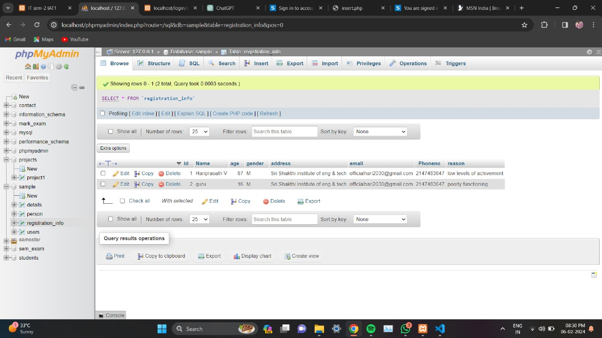

**REFERENCE:**

Yukselturk, E., Ozekes, S., & Turel, Y. K. (2014). Predicting dropout student: An application of data mining methods in an online education program. *European Journal of Open, Distance and E-Learning.,* *17*(1), 118–133.

Hu, Y.-H., Lo, C.-L., & Shih, S.-P. (2014). Developing early warning systems to predict students’ online learning performance. *Computers in Human Behavior,* *36*, 469–478.

Jia, P., & Maloney, T. (2015). Using predictive modelling to identify students at risk of poor university outcomes. *Higher Education,* *70*(1), 127–149.

Chun-Teck, L. (2010). Predicting preuniversity students’ mathematics achievement (published conference proceedings style). In: *International conference on mathematics education research, multimedia university*, Malaysia (pp. 299–306).

Adhatrao, K., Gaykar, A., Dhawan, A., Jha, R., & Honrao, V. (2013). Predicting students’ performance using ID3 and C4.5 classification algorithms. arXiv Preprint

Durairaj, M., & Vijitha, C. (2014). Educational data mining for prediction of student performance using clustering algorithms. *International Journal of Computer Science and Information Technologies,* *5*(4), 5987–5991.

Sales, A., Balby, L., & Cajueiro, A. (2016). Exploiting academic records for predicting student drop out: A case study in Brazilian higher education. *Journal of Data, Information and Management,* *7*(2), 166.

Kitchenham, B., & Charters, S. (2007). Guidelines for performing Systematic Literature reviews in SoftwareEngineering Version 2.3. *Engineering*, *45*(4), 1051.

Okoli, C., & Schabram, K. (2012). A Guide to Conducting a Systematic Literature Review of Information Systems Research. *SSRN Electron J [Internet].*. <https://doi.org/10.2139/ssrn.1954824>.

Moola, S. (2017). Checklist for analytical cross sectional studies. Joanna Briggs Institute Rev Man. (pp. 1–7).